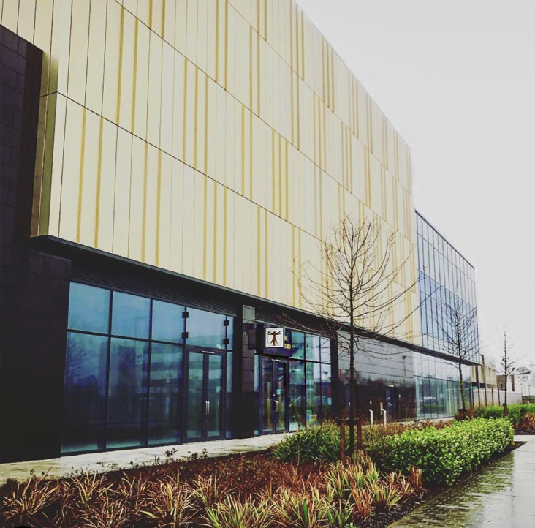

Welcome To Vitruvian Dental Studio

Unit 15
The Springs
Thorpe Park View
Leeds
LS15 8GH

Book Your First Appointment

Call us: 0113 322 0861

Online: www.VDSLeeds.co.uk

Email us: Hello@VDSLeeds.co.uk

Visit us: Come and see us in person

Opening Hours

Monday: 09:00-18:00
Tuesday: 09:00-18:00
Wednesday: 09:00-20:00
Thursday: 09:00-18:00
Friday: 09:00-18:00
Saturday: 09:00-18:00
Sunday: Closed

We are a purpose built dental practice situated just outside of Leeds which has been expertly designed to give you the best experience possible when visiting the dentist.

You first arrive at The Springs, a brand new and aesthetically designed outdoor retail park just outside of Leeds with unlimited free parking on site.
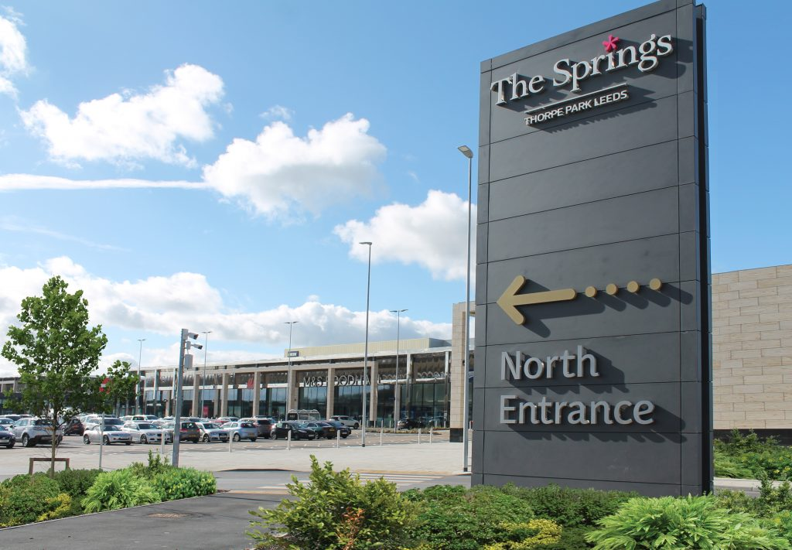

A short stroll down the modern central corridor and round the corner past Odeon and Nandos.
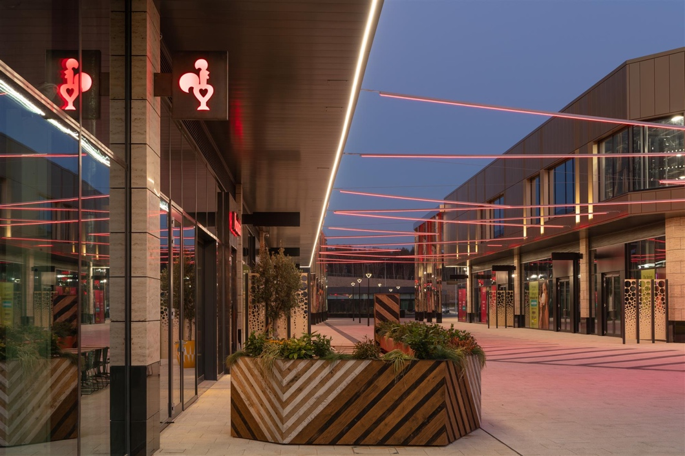

Takes you right outside our practice.

Come in to be greeted by a smiling face ready to answer any questions and show you to your own private waiting room.

PHOTO HERE OF INSIDE PRACTICE

Inside your private waiting room you will find yourself able to relax and unwind. You won’t have to worry about anybody else, just sit back, watch some TV, play some games on the games console, play your favourite music on the Alexa and charge your phone on the provided wireless charger whilst waiting to be called through.

PHOTO OF PRIVATE WAITING ROOMS

When called through you will find yourself in a state of the art equipped surgery with some of the last advancements in dentistry available for treatment.

PHOTO OF SURGERY

When lying back and having your treatment, there is a smart TV on the ceiling allowing you to catch up on your favourite Netflix shows whilst receiving treatment.

PHOTO OF LYING BACK IN CHAIR TV

Your First Appointment

Your initial appointment with us will firstly involve recording some information about your general health and lifestyle. This will be followed by an informal conversation to learn more about you as an individual and your treatment/dental health goals and what we can offer you to help get you there.

We will then carry out a comprehensive examination of all of the soft and hard tissues of the head, neck and mouth. We will take clinical photographs and any relevant X-rays.

Once the clinical examination is complete we will review our findings together with you and relate them to your treatment/dental health goals you outlined at the beginning of your consultation.

The final stage will be solidifying a treatment plan with you.

Let us take this opportunity to thank you for choosing us here at Vitruvian Dental Studio to care for your oral health.

2021 Fees (correct as of 02/01/2021)

General Pricelist

New Patient Exam £55
Routine Exam £45
Child Exam Free
Radiographs From £7.50
​
Restorations
Small White Filling. From £80
Med White Filling. From £120
Large White Filling From £150
​
Crowns
Gold Crown From £650
Metal Ceramic Crown From £675
White Crown From £750
​
Bridge From £800 per unit
​
Extractions
Front tooth From £120
Premolar From £150
Molar From £180
Surgical Extraction From £300
Childs Extraction From £80
​
Hygiene
Scale and Polish From £55
Gum Disease
Treatment From £95
Air Flow From £85
​
Root Canal Therapy
Front Tooth From £300
Premolar From £350
Molar From £400
​
Dentures
Partial Denture From £450 per arch
Complete Denture From £650 per arch

Cosmetic Pricelist

Invisalign From £2750
​
Teeth Whitening £349
​
Composite Bonding From £300 per tooth
​
Composite Edges From £150 per tooth
​
Porcelain Veneer From £640 per tooth
​
Mock-up of smile From £300

Specialist Treatment Pricelist: Oral Surgery and Implants

Implant Consultation £150
​
Implants Price per case
​
Surgical Extraction. From £300
​
Socket Preservation From £300
​
Block Bone Graft. From £1200
​
Sinus Lift. From £1000
​
Soft Tissue Biopsy £350

Other Surgery. Price per case

Fees for treatments may vary

For the most up-to-date information, visit;
https://www.vdsleeds.co.uk/price-list
Membership Plans (Prices start at just £13.95/month)

Pay-monthly membership plans a popular way to enjoy quality, private dental care.

They allow you the peace of mind that all of your routine examinations, hygiene appointments are covered as well as any emergency appointments.

You will also receive a 10% discount off all treatments offered at Vitruvian Dental Studio*

Your monthly fee includes:
- 2 Dental Health Checks per year, including X-rays
- 10% off usual fees*
- Regular Hygienist Appointments (type and frequency varies dependent on the plan)
- Emergency Appointments

To be accepted onto a payment plan you must be declared ‘dentally fit’ which means any current disease or outstanding treatment (i.e. decay, abscess, broken teeth, lost fillings etc) must be completed first.

The payment plan you will be offered is determined by your current dental health which will need to be assessed at your initial consultation.

If you would like further information on practice payment plans please contact us or mention it at your first appointment and we will be happy to advise.

*excluding cosmetic and specialist treatments

Keep up to date, follow us on social media:

@vitruvian.dental.studio.leeds

facebook.com/vitruviandentalstudioleeds/

Useful Information and Policies:
- ICO Registration Certificate
- CQC Registration Certificate
- Local Safeguarding Arrangements and Contact Numbers
- Right to Express a Preference for a Performer
- Confidentiality Policy
- Information on Oral Health
- GDC Standards
- Statement of Purpose
- Sepsis Information
- GDPR Information
- Privacy Notice
- Radiation Information

